Flask and MongoDB Atlas Assignment
To create a Flask application with an API route that returns JSON data and a frontend form that submits data to MongoDB Atlas.
1.API Route
Created a Flask application with an /api route. The route reads data from data.json and returns the data in JSON format using jsonify().

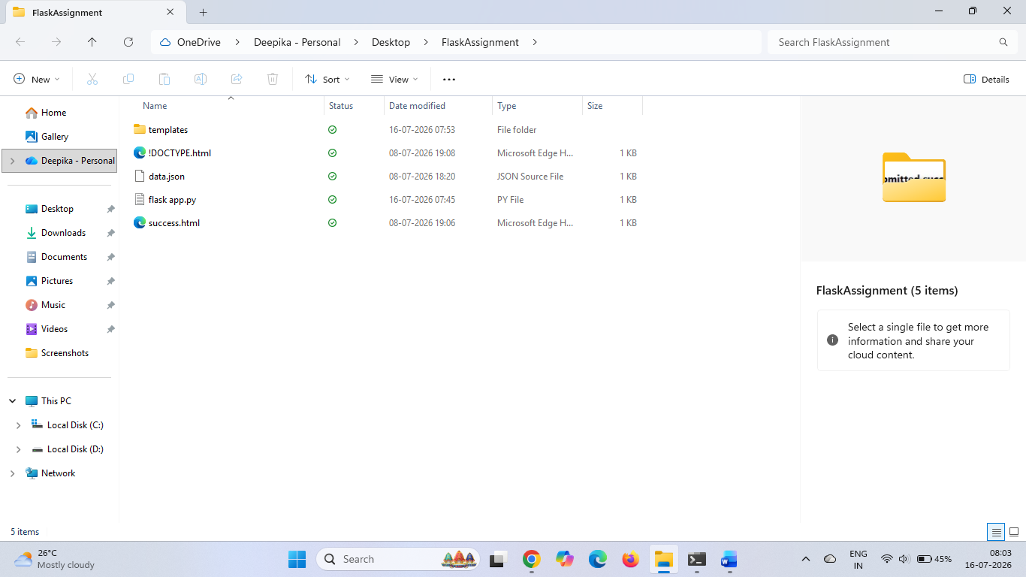

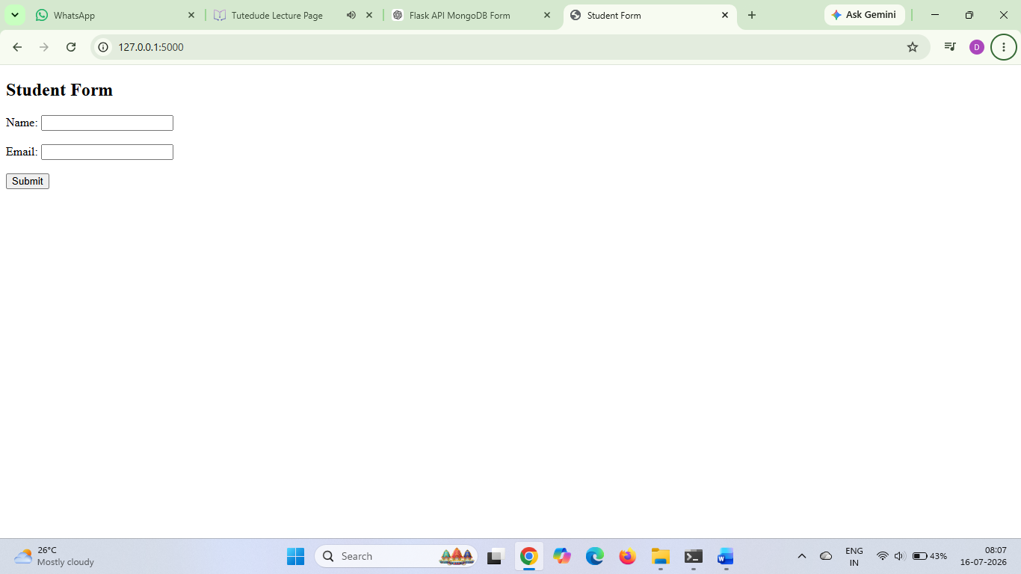
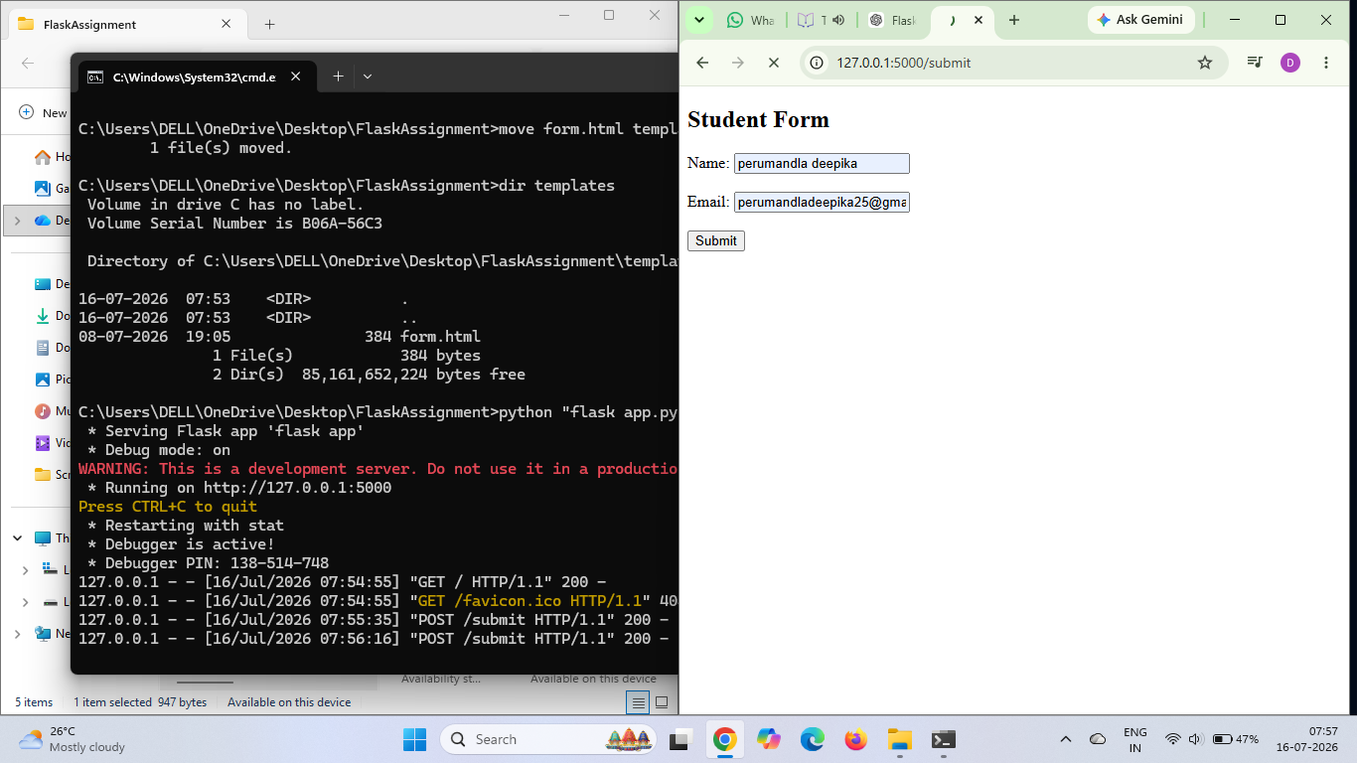
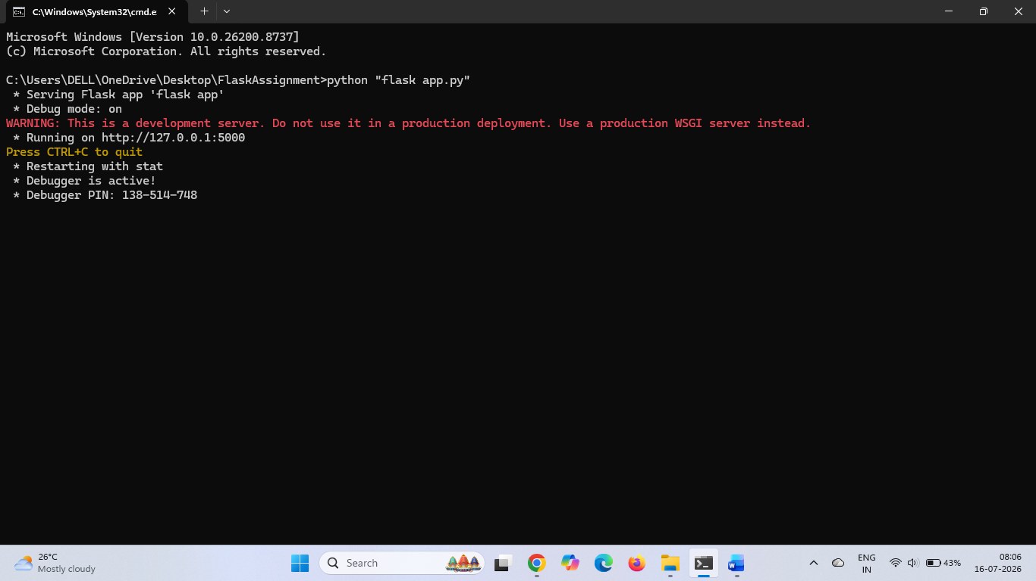

2. Frontend Form and MongoDB Atlas
A frontend form was created using HTML to collect user details such as Name and Email. The form sends the data to the Flask backend using the POST method. The backend processes the submitted data and stores it in MongoDB Atlas using PyMongo.
The application is designed to display a success page after successful submission. If an error occurs, the error message is displayed on the same page without redirection.

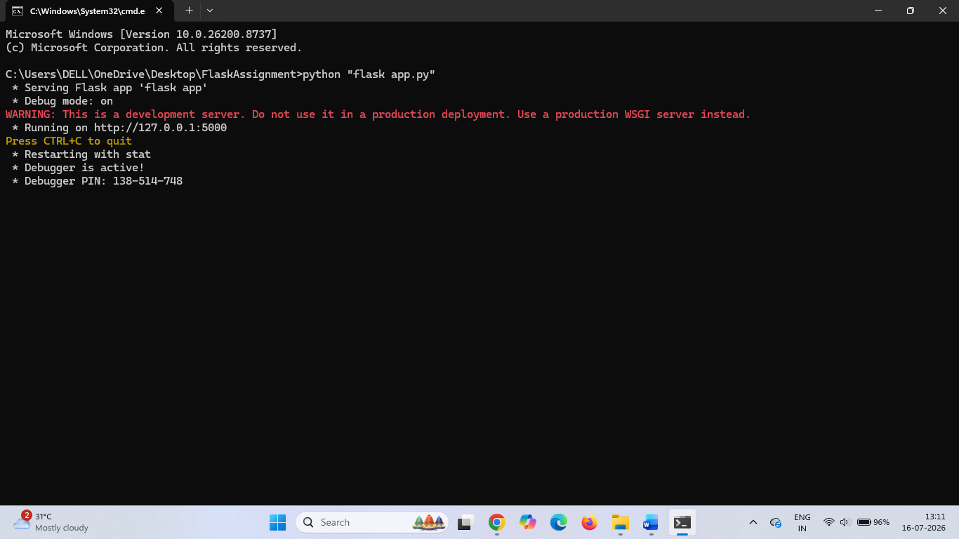

The frontend form was successfully submitted to the Flask backend. The terminal output shows POST /submit HTTP/1.1 200, indicating that the request was processed successfully without any server errors.

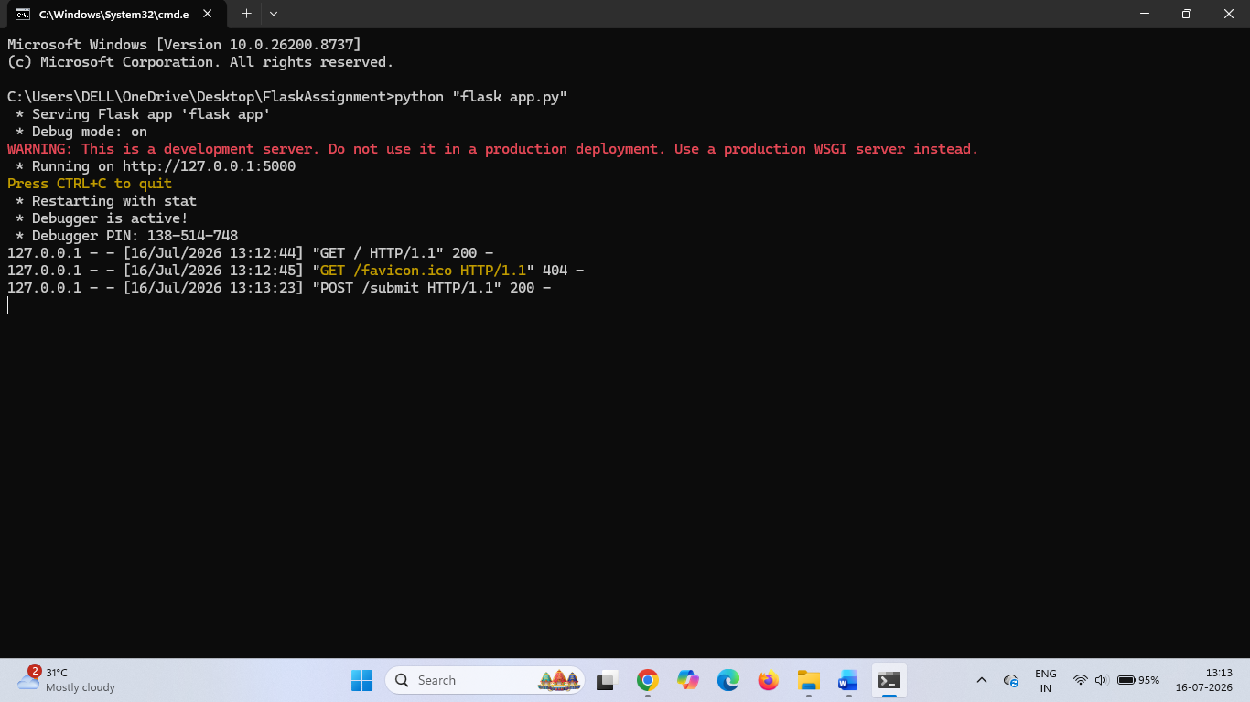

Commands Used
pip install flask pymongo dnspython
python "flask app.py"

Conclusion
The Flask application was successfully developed with an API route that reads data from a JSON file and returns it as a JSON response. A frontend form was also created to collect user information and submit it to the Flask backend. The application successfully processed form submissions and generated the expected output.

